Supervised By:

**Syed Qamar Askari**

|  |  |  |  |  |  |  |  |  |  |
| --- | --- | --- | --- | --- | --- | --- | --- | --- | --- |
| Literature Review 1.0  Global Optimization Using Meta-Heuristics | |  |  | | --- | --- | | Faiza Shanawar | 15140070 | | Haider Ali | 15140101 | | Mohsin Qamar | 15140104 | | Usama Imran | 15140098 | |

# Introduction:

Meta-Heuristic optimization techniques have become very popular over the last decade. These optimization techniques are being used in number of applications and proved themselves to be quite useful. Meta-Heuristic can be defined as higher level procedure designed to find, generate, or select a heuristic that may provide solution to optimization problem. Now, **Optimization Problem** can be elaborated as the problem of finding best solution from all feasible solutions. The main quality of meta-heuristic is that they are not problem specific, rather they are independent of the problem being solved. Characteristics of meta-heuristics are: they guide the search process, they explore the search space in order to find best possible solution, they are usually approximate and non-deterministic and they are not problem specific. These properties make them useful. The research work has been done on **nature inspired meta-heuristics**. Different problems are solved by different meta-heuristic techniques. But there is not even a single meta-heuristic algorithm that solves all the optimization problems therefore, research in this area is open. Researchers observe natural phenomenon and map it mathematically and then apply it on problems. Meta-Heuristics are useful in solving **NP-Hard** problems.

# Literature Review:

Meta-Heuristics may be classified into three categories: Swarm Intelligence, Physics Based, Evolutionary Algorithms. **Genetic Algorithm** is one of the most famous evolutionary algorithms. GA is inspired by Darwin’s theory of evolution. There is selection of population called “Chromosomes” and then they are subjected to crossover and mutation processes (Same as biological process). There are multiple applications of GA like: product designing, automotive designing, capacitated vehicle routing problem. [1]

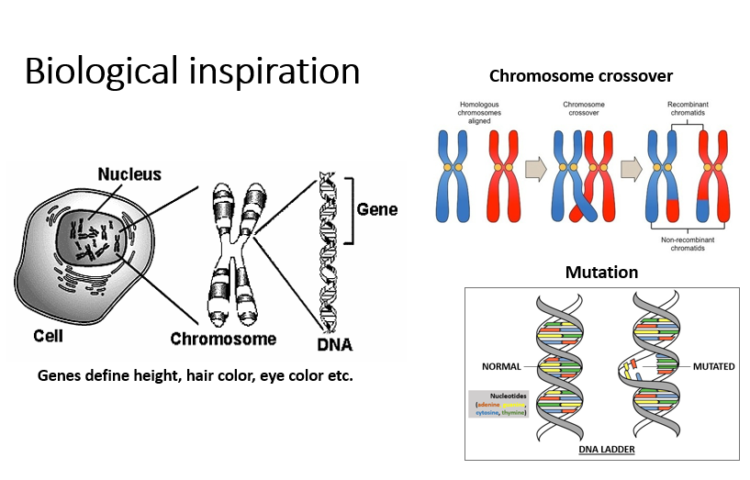

On the other hand, **Gravitational Search Algorithm** is Physics based algorithm which is, as the name suggests, inspired from Newton’s law of Gravitation. In this algorithm, every solution is treated as an object. And the object’s fitness is determined by the mass of that object, greater the mass, greater would be the fitness. The object of higher fitness attracts the object of lower fitness by following the rules of physics. Hence, this algorithm also has many useful applications. GSA is used in Economic Load Dispatch Problem, Energy Management System, Feature Subset Selection, Training the Neural Networks, Unit Commitment Problem [2].

**Particle Swarm Optimization** is Swam based intelligence algorithm which is inspired by swarm of fish, and birds. In this algorithm, every solution is treated as particle and there runs a swarm and all the particles moves around the global best solution. This algorithm is used in: multimodal optimization problems, production scheduling, power system operations, cryptarithmetics and many more. [3]

**Gray Wolf Optimization** is also well known meta-heuristic algorithm inspired by the pack of wolves which are hunting their prey. In this algorithm, each solution is treated as wolf and the highest fitness wolf is considered as “alpha”, second highest fit wolf is known as “beta”, third one is called “delta” and all the others are known as “omega”. All wolves follow the alpha wolf and they get the global best solution which is called “prey”. [4]

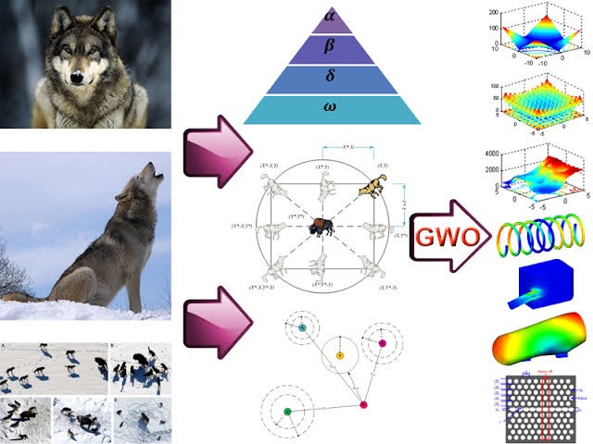

**Simulated Annealing** is also well known meta-heuristic algorithm. It mimics the annealing process in material processing when a metal cools and freezes into a crystalline state with minimum energy. The annealing process involves the careful control of temperature and its cooling schedule. [5]

**Soccer League Competition Algorithm** is also an optimization algorithm inspired by the optimization of football league competitions. All teams play 2 matches with other respective team. Total matches depend upon the total number of teams competing in the tournament by (M*(M-1))/2 (where M is the total no of teams). Each team wants to top the table at the end of each iteration. Teams which consists high performed or high fitness players has more probability to win matches against opponent teams. The team fitness is calculated by the average total fitness of the players. Each team has 11 fixed players and 11 substitute players. Every team has a SP (Star Player) and the tournament has an SSP (super star player) which has best fitness among team and best fitness among the whole tournament players respectively. The winning and losing team applying different strategies to perform better in next matches. Winning team fixed players try to imitate SP (star player) of the team and SSP (super star player) of the team. Substitutes of the winning team tries to improve their performance by making their fitness at least at the average of fixed players of the team. On the other hand, fixed players of losing team tries to improve their performance by changing position of players. The losing team substitutes pairs are being entered by a certain probability to make winning probability chances. At the end of the tournament, best teams buy players with best fitness and average and weak players are bought by weak team. SSP is the optimal and SP is the local optima of the solution. [6]

**Social Evolution Algorithm** is inspired by human’s interactions and beliefs. The individuals interact and share information to its neighbor. This Algorithm have three phases: initialization phase, evaluation phase and interaction phase. In this Algorithm, von Neumann Neighborhood architecture is adopted for building the neighborhood. Each Individual’s fitness and probability is calculated. The individuals Evaluate the neighbor based on co-operation factor (controlled parameter) and ability and productivity of the neighbor, then interact with the identified neighbor. The individual will not interact with any random solution in the society instead, they may interact more with the random neighbor in the von Neumann neighborhood architecture because of affinity and trust worthiness, but they are free to explore the society based on NCF (controlled parameter). Also, once the individual is selected for the interaction, the individual solution interacts with the selected individual for all the dimensions of the problem. Once the interaction is performed, individual evaluate the quality of interaction (QI). If the quality of interaction is inferior, interaction’s indecisive factor IDF is evaluated to decide on the interaction as negative or indecisive. All the indecisive interactions will undergo a second opinion process. In the second opinion process, the individual can consult an expert either from the neighborhood or from the society or a non-existing individual with the average capabilities to further evaluate the indecisive interaction before adopting the change to emerge and evolve. After the interaction phase, evaluate the fitness of the updated solutions and compare with the respective original solution to consider the best for next generation. Before the above process is repeated until a termination condition (maximum cycle number), calculate the probabilities of the individuals, average solution the best in the society for the next generation. [7]

Hence, there are many other algorithms that are inspires by either nature, physics or some rules. More nature inspired algorithms are: Whale Optimization, Dragonfly Algorithm, Moth-Flame Optimization Algorithm, Whirlpool optimization etc.

# References

|  |  |
| --- | --- |
| [1] | P. a. K. H. Kán, "Automated interior design using a genetic algorithm," pp. 1-10, 2017. |
| [2] | H. A. Nazmul SIDDIQUEa, "APPLICATIONS OF GRAVITATIONAL SEARCH ALGORITHM IN," *JOURNAL OF CIVIL ENGINEERING AND MANAGEMENT,* p. 10, 2016. |
| [3] | M. L. Settles, "An Introduction to Particle Swarm Optimization," 2005. |
| [4] | Seyedali Mirjalili a,⇑, Seyed Mohammad Mirjalili b, Andrew Lewis a, "Grey Wolf Optimizer," *Advances in Engineering Software,* p. 46–61, 2014. |
| [5] | S. Kirkpatrick, C. D. Gelatt, Jr., M. P. Vecchi, "Optimization by Simulated Annealing," *Science,* vol. 220, no. 4598, pp. 671-681, 1983. |
| [6] | N. Moosavian, "Soccer League Competition Algorithm," *International Journal of Intelligence Sciences,* 2014. |
| [7] | R. S. P. a. Gursaran, "Social Evolution: An Evolutionary Algorithm," *Advances in Intelligent Systems,* 2014. |